**Solve the quiz on a piece of paper with your name, signature and registration number on top of the page. Take a snapshot of your solution and paste it in this document and submit it.**

Q: Find the Minimum Cost Spanning tree, using the following graph, from ***root node 8*** using Prim’s algorithm.

Show all the calculations by completing the ***table*** as done in the class.

Fill only the first four rows of the table corresponding to the first four nodes extracted from Priority Queue.

***(Look at the Lecture Notes in Teams for the table calculations.)***

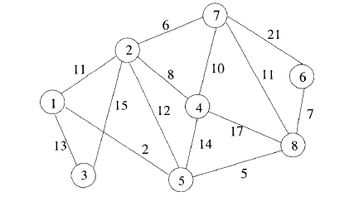

**Ans:**

